EX NO: 8 | POWER SPECTRAL DENSITY (PSD) ANALYSIS OF PHASE MODULATED (PM) SIGNALS USING MATLAB
DATE:

Objectives
i) To generate a Phase Modulated (PM) signal in MATLAB using specified carrier and message signal parameters.
ii) To compute the frequency spectrum of the PM signal using the Fast Fourier Transform (FFT). iii) To calculate and plot the Power Spectral Density (PSD) of the PM signal using MATLAB. iv) To identify the carrier component and sideband frequencies present in the PM spectrum. v) To analyze the effect of phase modulation on the spectral distribution and bandwidth of the transmitted signal.
vi)To investigate the influence of modulation index on the Power Spectral Density characteristics of the PM signal.
Procedure:
1. Open MATLAB and create a new script file.
2. Initialize the MATLAB workspace by clearing all variables, command window contents, and open figure windows using:
clc; clear; close all;
3. Define the message signal amplitude (AmA_mAm), message frequency (fmf_mfm), carrier amplitude (AcA_cAc), carrier frequency (fcf_cfc), sampling frequency (fsf_sfs), and phase sensitivity constant (kpk_pkp).
4. Generate the time vector required for simulation.
5. Generate the message signal and carrier signal.
6. Generate the Phase Modulated (PM) signal using the PM equation.
7. Compute the Fast Fourier Transform (FFT) of the PM signal.
8. Calculate the Power Spectral Density (PSD) from the FFT results.
9. Generate the frequency axis corresponding to the FFT output.
10. Plot the message signal, PM signal, frequency spectrum, and PSD using MATLAB plotting commands.
11. Determine the carrier frequency component and sideband frequencies from the spectrum. 12. Display the phase deviation and estimated bandwidth using the MATLAB Command Window.
13. Analyze the PSD plot and observe the spectral distribution around the carrier frequency. 14. Record the observations and verify the characteristics of Phase Modulation in the frequency domain.
PROGRAM (MATLAB CODE)
O1:
%% EXP 8 - Objective 1: PM Signal Generation in Time Domain
clc;
clear;
close all;

% Parameters
Am = 1; % Message amplitude (V)
fm = 100; % Message frequency (Hz)
Ac = 5; % Carrier amplitude (V)
fc = 1000; % Carrier frequency (Hz)
kp = pi / 2; % Phase sensitivity (rad/V)
fs = 20 * fc; % Sampling frequency (Hz)
t = 0:1/fs:4/fm; % Time vector (4 message cycles)

% Modulating and Carrier Signals
m = Am * sin(2 * pi * fm * t); % Modulating signal
c = Ac * sin(2 * pi * fc * t); % Carrier signal

% PM Signal Generation
pm = Ac * cos(2 * pi * fc * t + kp * m);

% Display
fprintf('--- Objective 1: PM Generation Parameters ---\n');
fprintf('Carrier Frequency (fc) : %d Hz\n', fc);
fprintf('Message Frequency (fm) : %d Hz\n', fm);
fprintf('Carrier Amplitude (Ac) : %d V\n', Ac);
fprintf('Message Amplitude (Am) : %d V\n', Am);
fprintf('Phase Sensitivity (kp) : %.4f rad/V\n', kp);

% Time-Domain Plots
figure('Name', 'Objective 1: PM Time Domain Generation', 'NumberTitle', 'off');

subplot(3,1,1);
plot(t, m, 'LineWidth', 1.2);
title('1. Modulating Message Signal m(t)');
xlabel('Time (s)'); ylabel('Amplitude (V)');
grid on;

subplot(3,1,2);
plot(t, c, 'LineWidth', 1.1);
title('2. Unmodulated Carrier Signal c(t)');
xlabel('Time (s)'); ylabel('Amplitude (V)');
grid on;

subplot(3,1,3);
plot(t, pm, 'r', 'LineWidth', 1.1);
title('3. Phase Modulated (PM) Signal');
xlabel('Time (s)'); ylabel('Amplitude (V)');
grid on;
O2:
%% EXP 8 - Objective 2: Frequency Spectrum Analysis via FFT
clc;
clear;
close all;

% Parameters
Am = 1;
fm = 100;
Ac = 5;
fc = 1000;
kp = pi / 2;
fs = 20 * fc;
t = 0:1/fs:4/fm;

% PM Signal
m = Am * sin(2 * pi * fm * t);
pm = Ac * cos(2 * pi * fc * t + kp * m);

% FFT Spectrum Computation
N = length(pm);
f = linspace(-fs/2, fs/2, N); % Frequency axis
PM_FFT = abs(fftshift(fft(pm))) / N; % Scaled double-sided FFT

% Plot Frequency Spectrum
figure('Name', 'Objective 2: FFT Spectrum of PM Signal', 'NumberTitle', 'off');
plot(f, PM_FFT, 'b', 'LineWidth', 1.2);
title('Magnitude Frequency Spectrum of PM Signal (FFT)');
xlabel('Frequency (Hz)');
ylabel('Magnitude');
xlim([-fc - 4*fm, fc + 4*fm]);
grid on;

fprintf('--- Objective 2 Verification ---\n');
fprintf('Sampling Frequency (fs) : %d Hz\n', fs);
fprintf('FFT Length (N) : %d points\n', N);
fprintf('Frequency spectrum centered and scaled successfully.\n');
O3:
%% EXP 8 - Objective 3: Power Spectral Density (PSD)
clc;
clear;
close all;

% Parameters
Am = 1;
fm = 100;
Ac = 5;
fc = 1000;
kp = pi / 2;
fs = 20 * fc;
t = 0:1/fs:4/fm;

% PM Signal
m = Am * sin(2 * pi * fm * t);
pm = Ac * cos(2 * pi * fc * t + kp * m);

% Power Spectral Density Computation
N = length(pm);
f = linspace(-fs/2, fs/2, N);
PM_FFT_shift = abs(fftshift(fft(pm)));
PSD = (PM_FFT_shift.^2) / (N * fs); % Power Spectral Density

% Plot PSD
figure('Name', 'Objective 3: Power Spectral Density of PM Signal', 'NumberTitle', 'off');
plot(f, PSD, 'r', 'LineWidth', 1.2);
title('Power Spectral Density (PSD) of PM Signal');
xlabel('Frequency (Hz)');
ylabel('PSD (Watts/Hz)');
xlim([-fc - 4*fm, fc + 4*fm]);
grid on;

fprintf('--- Objective 3 Verification ---\n');
fprintf('Max Spectral Density Peak : %.6f W/Hz\n', max(PSD));
fprintf('Power Spectral Density computation and plotting completed.\n');
O4:
%% EXP 8 - Objective 4: Carrier and Sideband Component Identification
clc;
clear;
close all;

% Parameters
fm = 100; % Modulating frequency (Hz)
fc = 1000; % Carrier frequency (Hz)
num_sidebands = 3; % Number of sideband pairs to evaluate

fprintf('--- Objective 4: Carrier and Sideband Frequencies ---\n');
fprintf('Carrier Frequency (fc) : %d Hz\n', fc);
fprintf('Message Spacing (fm) : %d Hz\n', fm);
fprintf('--------------------------------------------------\n');
fprintf(' Component | Frequency (Hz) | Formula \n');
fprintf('--------------------------------------------------\n');
fprintf(' Carrier | %4d | fc \n', fc);

for n = 1:num_sidebands
fprintf(' USB %d | %4d | fc + %d*fm \n', n, fc + n*fm, n);
fprintf(' LSB %d | %4d | fc - %d*fm \n', n, fc - n*fm, n);
end
fprintf('--------------------------------------------------\n');
O5:
%% EXP 8 - Objective 5: Phase Deviation and Carson Bandwidth
clc;
clear;
close all;

% Parameters
Am = 1; % Modulating amplitude (V)
fm = 100; % Modulating frequency (Hz)
kp = pi / 2; % Phase sensitivity (rad/V)

% Phase Deviation and Carson's Bandwidth
beta = kp * Am; % Phase deviation (radians)
BW_carson = 2 * (beta + 1) * fm; % Carson's Bandwidth (Hz)

% Display Analysis
fprintf('--- Objective 5: Bandwidth & Spectral Distribution ---\n');
fprintf('Message Amplitude (Am) : %.2f V\n', Am);
fprintf('Phase Sensitivity (kp) : %.4f rad/V\n', kp);
fprintf('Phase Deviation (Beta) : %.2f radians\n', beta);
fprintf('Estimated Carson Bandwidth : %.2f Hz\n', BW_carson);
fprintf('Single-Sided Span around fc : +/- %.2f Hz\n', BW_carson / 2);
O6:
%% EXP 8 - Objective 6: Influence of Beta on PSD Characteristics
clc;
clear;
close all;

% Fixed Parameters
Ac = 5;
fc = 1000;
fm = 100;
fs = 20 * fc;
t = 0:1/fs:4/fm;
N = length(t);
f = linspace(-fs/2, fs/2, N);

% Compare Different Modulation Indices (beta = kp * Am)
beta_cases = [0.5, 1.57, 3.0];
colors = ['b', 'r', 'k'];

figure('Name', 'Objective 6: Effect of Modulation Index on PSD', 'NumberTitle', 'off');

for i = 1:length(beta_cases)
b_val = beta_cases(i);
% Direct angle modulation form for PM with single tone
pm_test = Ac * cos(2 * pi * fc * t + b_val * sin(2 * pi * fm * t));

% PSD Calculation
PM_FFT_shift = abs(fftshift(fft(pm_test)));
PSD_test = (PM_FFT_shift.^2) / (N * fs);

subplot(3, 1, i);
plot(f, PSD_test, colors(i), 'LineWidth', 1.2);
title(sprintf('PSD for \\beta = %.2f (Carson BW \\approx %.1f Hz)', b_val, 2*(b_val+1)*fm));
xlabel('Frequency (Hz)'); ylabel('PSD (W/Hz)');
xlim([fc - 5*fm, fc + 5*fm]);
grid on;
end
OUTPUT:
O1:
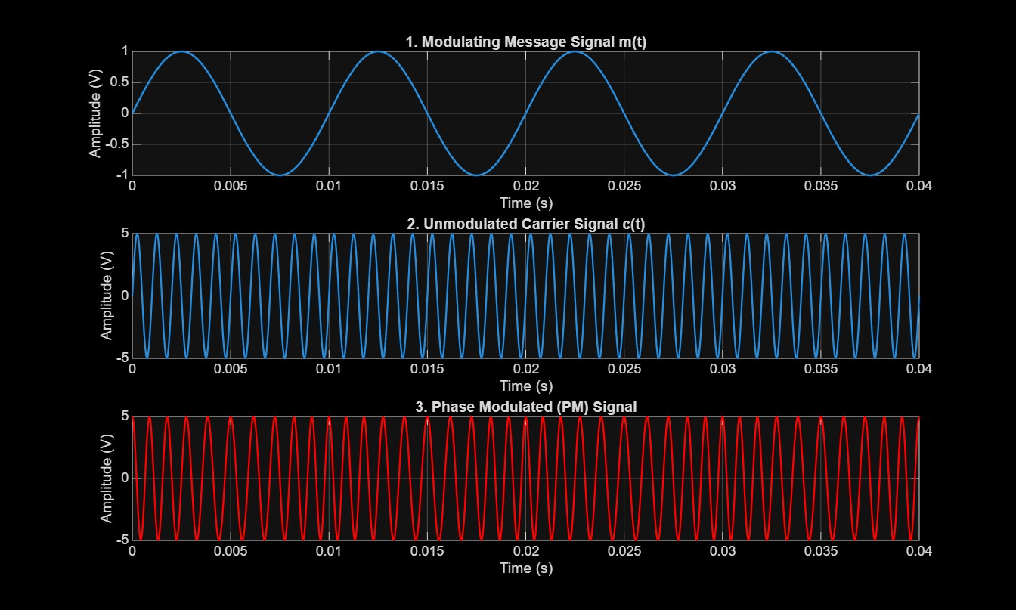
O2:
--- Objective 2 Verification ---
Sampling Frequency (fs) : 20000 Hz
FFT Length (N) : 801 points
Frequency spectrum centered and scaled successfully.
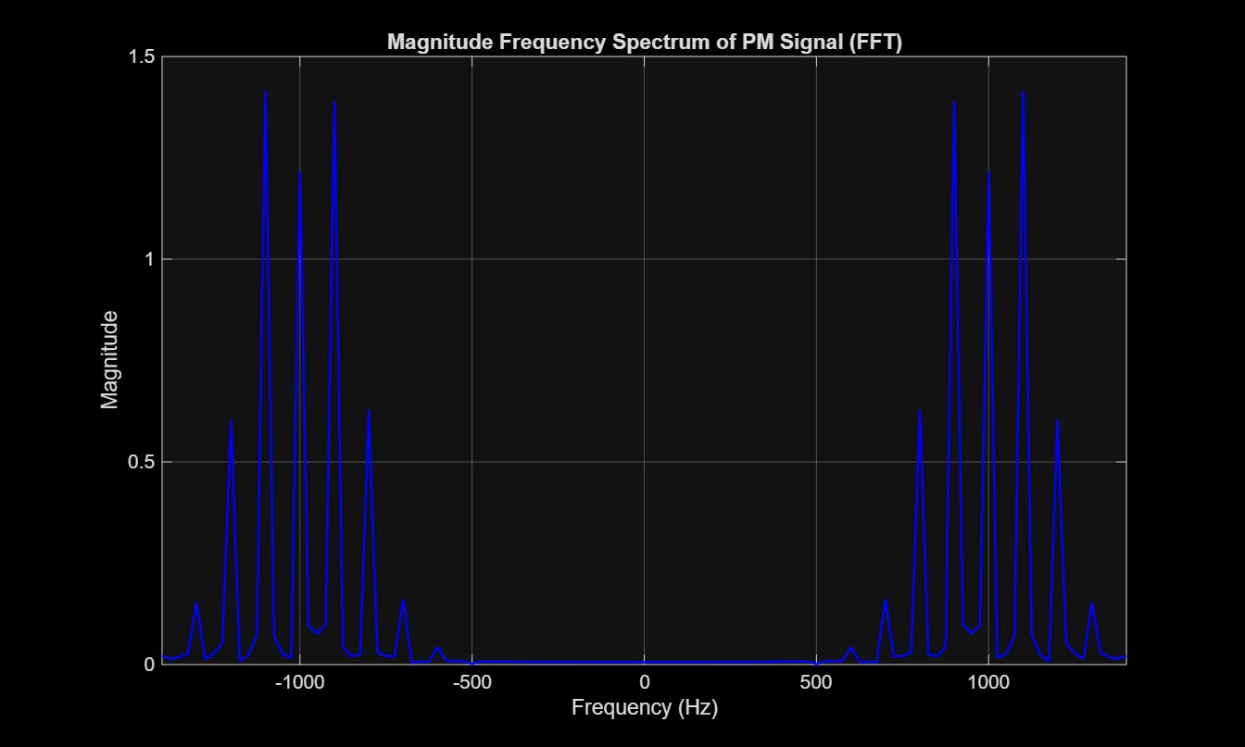
O3:
--- Objective 3 Verification ---
Max Spectral Density Peak : 0.080052 W/Hz
Power Spectral Density computation and plotting completed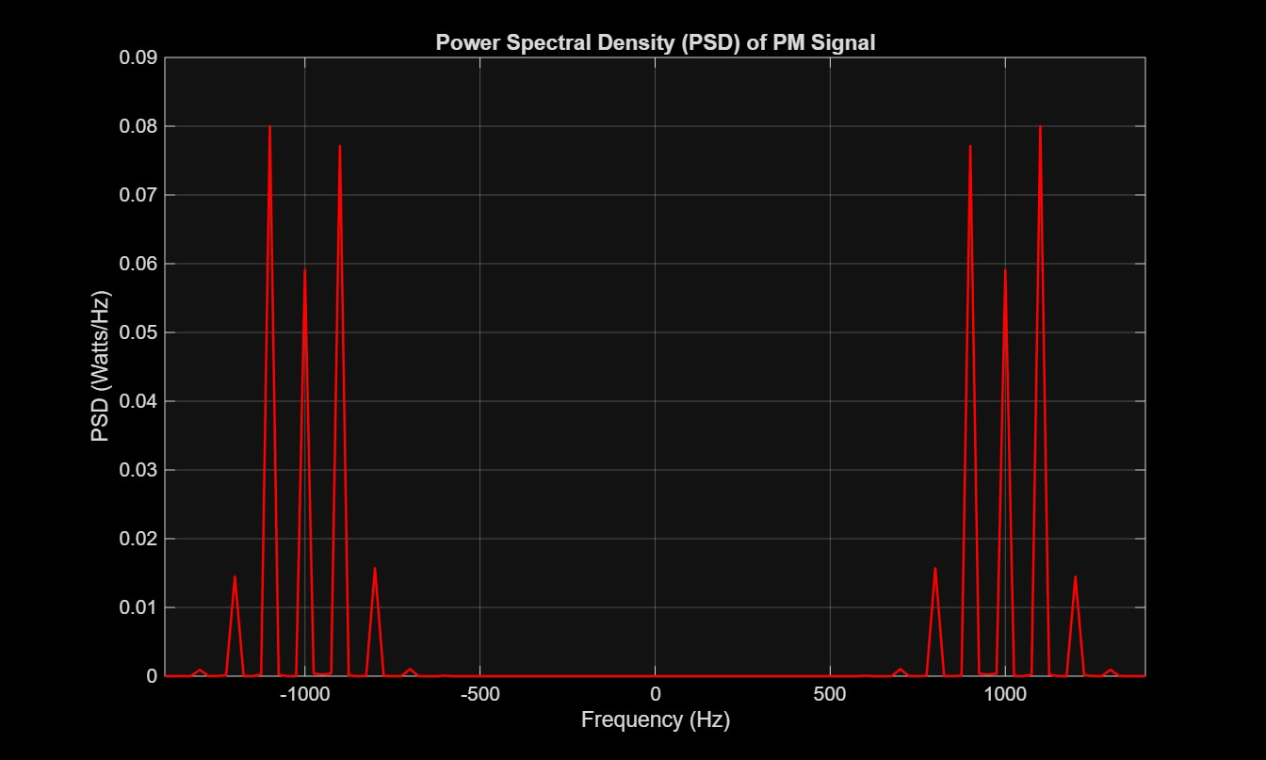
O4:
--- Objective 4: Carrier and Sideband Frequencies ---
Carrier Frequency (fc) : 1000 Hz
Message Spacing (fm) : 100 Hz
--------------------------------------------------
Component | Frequency (Hz) | Formula
--------------------------------------------------
Carrier | 1000 | fc
USB 1 | 1100 | fc + 1*fm
LSB 1 | 900 | fc - 1*fm
USB 2 | 1200 | fc + 2*fm
LSB 2 | 800 | fc - 2*fm
USB 3 | 1300 | fc + 3*fm
LSB 3 | 700 | fc - 3*fm
--------------------------------------------------
O5:
--- Objective 5: Bandwidth & Spectral Distribution ---
Message Amplitude (Am) : 1.00 V
Phase Sensitivity (kp) : 1.5708 rad/V
Phase Deviation (Beta) : 1.57 radians
Estimated Carson Bandwidth : 514.16 Hz
Single-Sided Span around fc : +/- 257.08 Hz

O6:
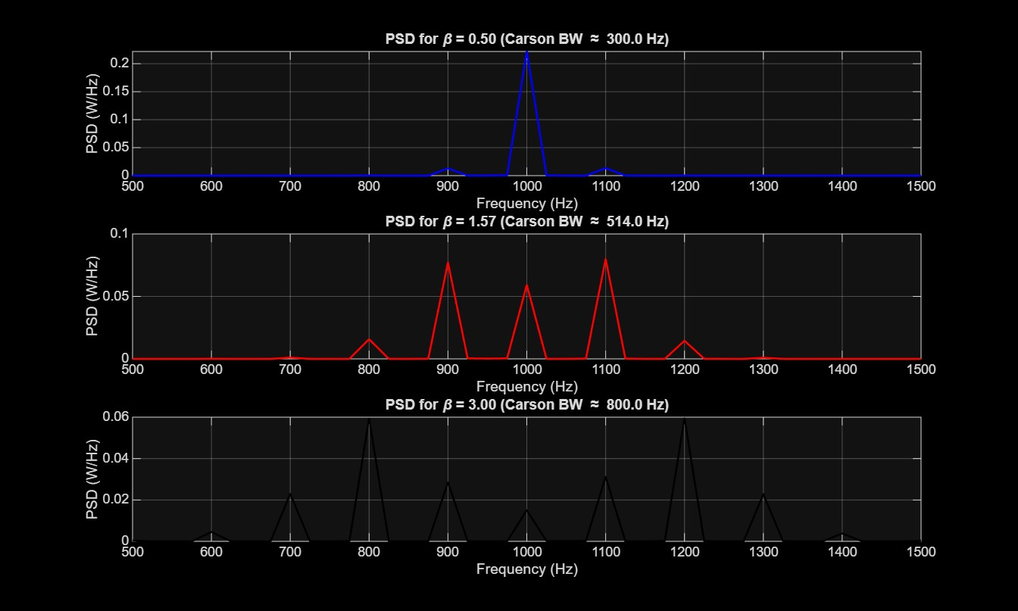
RESULT:

